**A**

**PROJECT REPORT**

**On**

**“Health Care Management System”**

**SUBMITTED IN PARTIAL FULFILLMENT OF THE**

**REQUIREMENT FOR THE AWARD OF THE DEGREE**

**OF**

***Bachelor of Computer Application***



*(Session 2019-2021)*

|  |  |
| --- | --- |
| **Submitted To :-** | **Submitted By :-** |
| Mr. Ashish sen | Jaya Tailor |
| Asst. Professor | BCA IIIrd Year |
|  |  |



**Department of Computer Science**

**VISION COLLEGE OF COMMERCE**

**Udaipur Road, CHITTORGARH**

**(Affiliated to MOHAN LAL SUKHADIYA UNIVERSITY, UDAIPUR)**

**Email: - vision_mgmt@yahoo.com**

**Website: -** [www.visionmanagement](http://www.visionmanagement)

**Statement of Originality**

In accordance with the requirements for the degree of **Bachelor in Computer Application**, in Faculty of **Computer Science Application**, I present this report Entitled “**Health Care Management System”**. This report is complete under the Supervision of **Mr. Ashish Sen (Asst. Professor)**.

I declare that the work presented in the report is my own work except as acknowledged in the text and footnotes, and that to my knowledge this material has not been submitted either in whole or in part, for a degree at this School or at any other such Institution.

This work has not submitted elsewhere for award of other degree.

Date: …/…/….. Name & Signature of student

Place: - Vision College of Commerce Jaya Tailor

Chittorgarh(BCA IIIrd Year

**Vision College of Commerce**





***CERTIFICATE***

*This is to certify that the work which is being presented in PROJECT entitled “Student Result Management System” Submitted by Balwant Kumar Sharma Student of final year Bachelor Of Computer Application (BCA) in partial fulfillment for award of degree of Bachelor of Computer Application (2016-2019) is a record of student’s work carried out by them under our guidance and supervision of Miss. Smita Sankhla Faculty of Computer Science Department.*

*This work has not been submitted elsewhere for award of any other degree.*

*Date:*

*Place:*

*Signature of Project Guide* *Signature of Project Coordinator*

*(Miss. Smita Sankhla) (Miss. Smita Sankhla)*

*Asst. Professor* *Asst. Professor*

**ACKNOWLEDGEMENT**

It is a pleasure to represent my report on **Student Result Management System** as a project. I would like to express my deep gratitude to my teach instructor and guide Asst. Professor , **Miss. Smita Sankhla** for giving us all necessary encouragement and guidance for overcoming all the difficulty that I had faced in the task. I thank him to guiding us from beginning to the end.

I am highly graceful to **Dr. Sadhana Mandloi (Director - Vision College of Commerce)** for providing me this opportunity and support.

I am highly indebted to **All the Faculty member of Computer Science Department** for their cooperation, guidance & Support.

I am also grateful to my friends who always stood by my side giving their worthily advice in making the project.

Last but not the least to express my indebtedness to **Miss Smita Sankhla (Asst. Professor)** the coordinator of the project for his constant motivation regarding this project.

**Abstract**

The application will manage the information about various students enrolled in this course in different years, the subjects offered during different semesters of the course, the marks obtained by the various students in various subjects in different semesters. The application will greatly simplify and speed up the result preparation and management process.

**CHAPTER 1**

**INTRODUCATION**

* 1. **INTRODUCATION OF HEALTH CARE SYSTEM**

Health care management system is a web application developed for hospitals to manage staff data and patients data effectively. the main aim of developing “HEALTH CARE MANAGEMENT SYSTEM” is to computerize the Front Office Management of Hospital. Hospital Management System is designed for multi-specialty hospitals, to cover a wide range of hospital administration and management processes. The project Hospital Management system includes registration of patients, storing their details into the system, and also computerized billing in the pharmacy, and labs. Healthcare is a field in which accurate record keeping and communication are critical. The software has the facility to give a unique id for every patient and stores the details of every patient and the staff automatically. With the increase of demand in hospitals, we need effective data management system for handling patient’s data, staff data and treatment details in an effective way. It deals with the collection of patient’s information, diagnosis details, etc. It includes a search facility to know the current status of each room. User can search availability of a doctor and the details of a patient using the id.

The main intention of introducing this system is to reduce the manual work at Health center counters. Quicker processing of receipt would mean better service to the patients . It would also help in the complexity of maintaining the records manually and thus less time is wasted on rework. The system is used to enter the patient details and to enter the details about the health center and the details about the in-patient and out-patient in detail and about the reports of the patients . User can login into the The Hospital Management System using a username and password. To develop a Health Center Management system, we take care of patient registration, drug information and concerns such as drug inquiries and complaints. It is accessible either by an administrator or receptionist. Only they can add data into the database. Proper maintenance of the drug information timely dispatching of the drugs from the main stores to the pharmacy and also maintenance of daily dispatching of the drugs to the out patients from the pharmacy to the out patients . The main function of the system is register and store patient details and doctor details and retrieve these details as and when required, and also to manipulate these details meaningfully System input contains patient details, diagnosis details, while system output is to get these details on to the screen. Every sort of task is performed by the system, such as registering different types of persons (i.e employees , students and others) ,enquiries, and complaints etc reducing much paper work and burden of file storage. Hospital Management System is powerful, flexible, and easy to use and is designed and developed to deliver real conceivable benefits to hospitals.

Hospital Management System enables you to develop your organization and improve its effectiveness and quality of work Also the latest information is right available for the officials and executives wherever they require. The system also facilitates the pharmacist to enquire about the drugs and about the stock to be ordered and about the expiry date . The data are well protected for personal use and makes the data processing very fast. Towards this achievement the computerization of the Health Center will help greatly in maintaining of proper information about the out patients who are eligible for the free services and the patients who are not eligible for the free services , drug information , patients records ,and daily dispatching of the drugs to various patients .

**CURRENT HEALTH CARE SYSTEM –**

In current healthcare, information is conveyed from one healthcare professional to another through paper notes or personal communication. It is very difficult to analyze the usage percentage of hospital resources, Bed occupation Ratio, Administration, Laboratory information even in a single center. Then we can expect the complexity while integrating multi-specialty Medicare Centers. For example, in the United States, electronic communication between physicians and pharmacists is not typically employed but, rather, the physician writes a prescription on paper and gives it to the patient. The patient carries the prescription to the pharmacy, waits in line to give it to a pharmacist, and waits for the pharmacist to fill the prescription. Room Reservations, Doctor Appointment Schedules, Operation Schedules, and Medicine indentation information is very difficult to maintain and share among the different Medicare Centers. To improve this process, the prescriptions could be communicated electronically from the physician to the pharmacist, and the human computer interfaces for the physicians, nurses, pharmacists and other healthcare professionals could be voice enabled. The current manual system is slow laborious and error prone to computerize the same for quicker efficient results and customer satisfaction

OBJECTIVE OF PROPOSED HEALTH CARE MANAGEMENT SYSTEM

1) user can store information about the Patients that come to the hospital.

2) Information about Patients is done by just writing the Patients name, age and gender.

3) Generating bills. This system also help user in generating bills.

4) Bills are generated by recording price for each facility provided to Patient on a separate sheet and at last they all are summed up.

5) This system also store information related to diagnosis given to Patients.

6) Diagnosis information of patients is generally recorded on a document, which contains Patient information.

7) This system also store information of the Immunization provided to children/patients.

8) Immunization records of children are maintained in pre-formatted sheets, which are kept in a file.

9) Keeping information about various diseases and medicines available to cure them.

10) Information about various diseases is not kept as any document. Doctors themselves do this job by remembering various medicines.

### MODULES OF HEALTH CARE MANAGEMENT SYSTEM

Admin module

User module (patient)

Doctor module

Nurse module

Pharmacist module

Laboratory module

Accountant module

Admin module:

Using this module admin can manage department of hospitals, user, doctor, nurse, pharmacist, laboratory accounts. Using this module he check appointment of doctors. This module also allow user to check transaction reports of patient payment. he can check Bed ,ward, cabin status in the hospital. blood bank report can also check through this module. he can also check medicine status of hospital stock.

Admin can also check following report using this module.

operation report

birth report

diagnosis report

**1.3 METHODOLOGY DEVELOPMENT MODEL**

* **System Design -**the requirement specification from first phase are in this phase and the system design is prepared. This system design helps in specifying hardware and system requirements and helps in defining the overall system architecture.
* **Implementation –** With input from the system design, the system is first development in small program called units, which are integrated in the next phase. Each unit is development and tested for its functionality, which is referred to as Unit Testing.
* **Integration and Testing –** All the units developed in the implementation phase are integrated into a system after testing of each unit. Post integration the entire system tested for any faults and failures.
* **Deployment of system –** Once the functional and non-functional testing is done; the product is deployed in the customer environment or released into the market.
* **Maintenance –** There are some issues which come up in the client environment. To fix those issues, patches are released. Also to enhance the product some better versions are released. Maintenance is done to deliver these changes in the customer environment.
  1. **TOOLS AND TECHNIQUE**

1. Php
2. XAMPP
3. MYSQL
4. HTML
5. VS CODE
6. Java Script
7. Css

**3**

* + 1. **PHP**

Hypertext Pre-Processor (or simply PHP) is a server-side Scripting language designed for Web development, but also used as a general-purpose programming language. It was originally created.

PHP tutorial for beginners and professionals provides in-depth knowledge of PHP scripting language. Our PHP tutorial will help you to learn PHP scripting language easily.

This PHP tutorial covers all the topics of PHP such as introduction, control statements, functions, array, string, file handling, form handling, regular expression, date and time, object-oriented programming in PHP, math, PHP MySQL, PHP with Ajax, PHP with jQuery and PHP with XML.

|  |
| --- |
|  |

PHP is an open-source, interpreted, and object-oriented scripting language that can be executed at the server-side. PHP is well suited for web development. Therefore, it is used to develop web applications (an application that executes on the server and generates the dynamic page.).

PHP was created by **Rasmus Lerdorf in 1994** but appeared in the market in 1995. **PHP 7.4.0** is the latest version of PHP, which was released on **28 November**. Some important points need to be noticed about PHP are as followed:

* PHP stands for Hypertext Pre-processor.
* PHP is an interpreted language, i.e., there is no need for compilation.
* PHP is faster than other scripting languages, for example, ASP and JSP.
* PHP is a server-side scripting language, which is used to manage the dynamic content of the website.
* PHP can be embedded into HTML.
* PHP is an object-oriented language
* **4**
* PHP is an open-source scripting language.
* PHP is simple and easy to learn language.



* + 1. **XAMPP**

XAMPP is an abbreviation where X stands for Cross-Platform, A stands for Apache, M stands for MYSQL, and the Ps stand for PHP and Perl, respectively. It is an open-source package of web solutions that includes Apache distribution for many servers and command-line executables along with modules such as Apache server, MariaDB, PHP, and Perl. XAMPP helps a local host or server to test its website and clients via computers and laptops before releasing it to the main server. It is a platform that furnishes a suitable environment to test and verify the working of projects based on Apache, Perl, MySQL database, and PHP

**5**

through the system of the host itself. Among these technologies, Perl is a programming language used for web development, PHP is a backend

scripting language, and MariaDB is the most vividly used database developed by MySQL. The detailed description of these components is given below. **6**

**1.4.3MYSQL**

MySQL is a fast, easy-to-use RDBMS being used for many small and big businesses. MySQL is developed, marketed and supported by MySQL AB, which is a Swedish company. MySQL is becoming so popular because of many good reasons −

* MySQL is released under an open-source license. So you have nothing to pay to use it.
* MySQL is a very powerful program in its own right. It handles a large subset of the functionality of the most expensive and powerful database packages.
* MySQL uses a standard form of the well-known SQL data language.
* MySQL works on many operating systems and with many languages including PHP, PERL, C, C++, JAVA, etc.
* MySQL works very quickly and works well even with large data sets.
* MySQL is very friendly to PHP, the most appreciated language for web development.
* MySQL supports large databases, up to 50 million rows or more in a table. The default file size limit for a table is 4GB, but you can increase this (if your operating system can handle it) to a theoretical limit of 8 million terabytes (TB).

6

* MySQL is customizable. The open-source GPL license allows programmers to modify the MySQL software to fit their own specific env

* **MySQL** is an open-source relational database management system that works on many platforms. It provides multi-user access to support many storage engines and is backed by Oracle. So, you can buy a commercial license version from Oracle to get premium support services.
* **My SQL** support large database, up to 50 million rows or more in a table. The default file size limit for a table 4 GB, but you can increase this (if your operating system can handle into a theoretical limit of 8 million terabyte (TB).

* + 1. **HTML**

HTML stands for hypertext markup language, and it’s used to lay out the basic structure of a website. You can build a simple website with HTML alone, including different font sizes and types, paragraphs, photos, background colors and other basic features. If you want to make your site look modern and nicely organized, though, you’ll need to learn additional languages like CSS and JavaScript

* HTML stands for Hyper Text Markup Language
* HTML is the standard markup language for creating Web pages
* HTML describes the structure of a Web page
* HTML consists of a series of elements
* HTML elements tell the browser how to display the content

**7**

* HTML+ was published by the IETF as an Internet Draft and was a competing proposal to the Hypertext Markup Language draft. It expired in July 1994. November 1994 First draft (revision 00) of HTML 2.0 published by IETF itself (called as "HTML 2.0" from revision 02), that finally led to publication of RFC 1866 in November 1995.
* HTML element are the building blocks of HTML pages. With HTML constructs images and other objects such as interactive forms may be embedded into the rendered page. HTML provides a means to create structure document by denoting structural semantics for text such as headings, paragraphs, lists, links, quotes and other items.
  + 1. **JAVA SCRIPT**

**JavaScript**  often abbreviated as JS, is high-level, interpreted programming language. It is a language which is also characterized as dynamic, weakly typed, prototype-based multi-paradigm.

Alongside HTML and CSS, JavaScript is one of the three core technolgies of the Word Wide Web. JavaScript enables interactive web page and thus is an essential part od web application. The vast majority of website use it, and all major web browsers have a dedicated JavaScript engine to execute it.

The programs in this language are called scripts. They can be written right in a web page’s HTML and run automatically as the page loads. Scripts are provided and executed as plain text. They don’t need special preparation or compilation to run. In this aspect, JavaScript is very different from another language called Java.

**JavaScript** is a lightweight, cross-platform, and interpreted scripting language. It is well-known for the development of web pages, many non-browser environments also use it. JavaScript can be used for [**Client-side**](https://www.geeksforgeeks.org/server-side-client-side-programming/) developments as well as [**Server-side**](https://www.geeksforgeeks.org/server-side-client-side-programming/) developments. JavaScript contains a standard library of objects, like [**Array**](https://www.geeksforgeeks.org/arrays-in-javascript/), [**Date**](https://www.geeksforgeeks.org/javascript-date-objects/), and [**Math**](https://www.geeksforgeeks.org/javascript-math-object/), and a core set of language elements like **operators**, **control structures**, and **statements**.

**8**

**1.4VS Code**

Introduction to Visual Studio Code Visual Studio Code is a code editor in layman’s terms. Visual Studio Code is “a free-editor that helps the programmer write code, helps in debugging and corrects

1. the code using the intelli-sense method ”. In normal terms, it facilitates users to write the code in an easy manner.

* It uses the various platforms of Microsoft software development software like Windows store, Microsoft Silverlight, and Windows API, etc. It is not a language-specific IDE as you can use this to write code in C#, C++, VB (Visual Basic), Python, JavaScript, and many more languages.

**1.4.6 CSS**

CSS stands for Cascading Style Sheets. It describes how Html elements should be displayed on screen. It is a powerful tool for web designers to change the design and control over web pages that how it should be displayed. It is supported by all browsers and is designed primarily to separate the document content from document presentation.

It was developed by W3C (World Wide Web Consortium) in 1996. Term cascading in CSS implies the fact that you can apply multiple style sheets to a single web page. Extension used to save CSS files is "css".

* 1. **SPECIFICATION REQUIREMENT**

External Interface

This interface will be actual interface through which the user will communication with the application and perform the desired tasks.

Admin Login

**9**

**Role:** Admin wishes to login to the system

**Precondition:** Username and Password

**Success end Condition:** Main option of screen display

**Failed end Condition:** User has entered incorrect Username and Password or both.

* Software
* Product
* Features
* Online Restaurant System
* Login Information System
* Description
* The system will maintain the login information of its user to enter in to the software
* Validating Checks
* Administrator need to login the unique id and Password.
* Contact number should have maximum 10 digits.
* All the details must be fill up.
* Email adders should be in the proper format.
* Sequencing information
* Login information should be filed before the user allowed.
* Error Handling
* If user doesn’t filled up validate information then the system display error message for user and request to enter the validate information.
* Performance required
* Security
* Maintainability

**10**

* 1. **LOGICAL DATABASE**

|  |  |  |  |  |  |  |
| --- | --- | --- | --- | --- | --- | --- |
| **Column** | **Type** | **Null** | **Default** | **Links to** | **Comments** | **MIME** |
| Id(primary) | Int (1) | No |  |  |  |  |
| name | Varchar (250) | No |  |  |  |  |
| email | Varchar (50) | No |  |  |  |  |
| Password | Varchar (250) | No |  |  |  |  |

**Indexes**

|  |  |  |  |  |  |  |  |  |
| --- | --- | --- | --- | --- | --- | --- | --- | --- |
| **Keyname** | **Type** | **Unique** | **Packed** | **Column** | **Cardinality** | **Collation** | **Null** | **Comment** |
| PRMARY | BTREE | YES | No | id | O | A | No |  |

|  |  |  |  |  |  |  |
| --- | --- | --- | --- | --- | --- | --- |
| **Column** | **Type** | **Null** | **Default** | **Links to** | **Comments** | **MIME** |
| Id(primary) | Int (1) | No |  |  |  |  |
| name | Varchar (250) | No |  |  |  |  |
| email | Varchar (50) | No |  |  |  |  |
| Password | Varchar (250) | No |  |  |  |  |

**Fig. 1.2 Logical Database**

**1.7 DATA MODEL**

A data model is a type of data model that determines the logical structure of a database and fundamentally determines in which manner data can be stored,

Organized and manipulated.

**1.7.1 LEVEL 0 DFD**

**USE A CASE DIAGRAME**

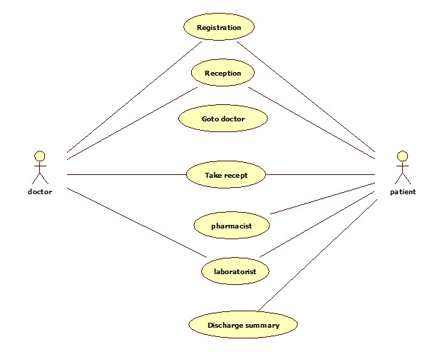

An Introduction to Healthcare Project Management. Hospital management system project. Project Management in Health Care Setting.

• Health Care & Project Management. The health care By instituting new projects, health care organizations should build project management systems. the Health Systems Project is an initiative of the Government TNHSP to appoint Auditors for Emergency Management Services & Mortuary Van Services. Online Health Care System In Java Project Codes and Scripts Downloads Free. Online Resource Management system is our year 2 project, Mobile based Primary Health Care System for Health care management systems in the world improve the efficiency of healthcare delivery. In India, the project. Healthcare Project Manager Jobs available on Indeed.com. one search. Of ten years healthcare project management Trauma Informed Care Project Manager.

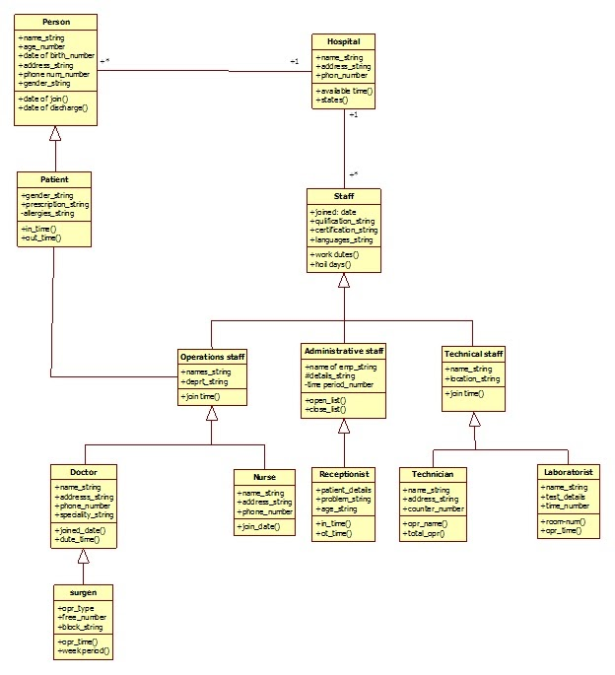

**CHAPTER 2**

**TASK AND ACTIVITES PERFORMED**

**2.1 PROFILE OF PROBLEMS**

* Physical Activity and Nutrition.
* Overweight and Obesity.
* Tobacco.
* Substance Abuse
* HIV/AIDS
* Mental Health
* Injury and Health
* Environmental Quality
* Immunization
* Access to Health Care

**2.2 STRUCTURE OF THE PROJECT**

* **Before Login**
* Login
* Register
* About Us
* Contact Us
* After Administrator Login

**2.3 SCOPE AND FEASIBILITY**

Feasibility study determines the viability of an idea or a business initiative. The thorough analysis of the practicality and sustainability of the business idea brings together all the elements of knowledge that helps in realizing if the project justifies the investment.

**2.4 SYSTEM ANALYSIS**

It is a process of collecting and interpreting facts, identifying the problem, and decomposition of a system into its components. System analysis is conducted for the purpose of studying a system or its part in order to identify its objectives. It is a problem-solving technique that improves the system and ensures that all the components of the system work efficiently to accomplish their purpose.

The objective of the system analysis activity is to develop structure system specification for the proposed system. Would do; independent of the technology, which will be used to implement these requirements. The technology, which will be used to implement these requirements. The structured system specification will be used to implement these requirements.

The essential model may itself consist of multiple models. Modelling different aspect of the system. The data flow diagram may model time dependent behaviour of the system. The essential model thus consists of the following,

* Context diagram
* Levelled data flow diagram
* Process specification for elementary bubbles
* Data dictionary for the flow and stores on the DFDs.

**19**

**2.5 SYSTEM DESIGN**

System design involves transformation of the user implementation model into software design. The design specification of the proposed system consists of the following:

* Data Scheme
* Structure Charts
* Pseudo codes for the modules in structure charts

**2.6 TEST GENERATION**

This activity generates a set of test data. Which can be used to test the new system before accepting it. In the test generation phase all the parts are come which are to be tested to ensure that system does not problem any error. If these are some errors then we remove then and further it goes for accepting.

CHAPTER-4

**IMPLEMENTATION**

**4.1IMPLEMENTATION**

This activity includes programming , testing and integration of modules into a progressively more complete system , Implementation is the process of collect all the required parts and assemble theem into a major product

**4.2 HARDWARE AND SOFTWARE REQUIREMENT**

**4.2.1 HARDWARE REQUIREMENT**

|  |  |
| --- | --- |
| PROCESSOR | Intel(R) Core(TM) i7-4600U CPU |
| Secondary memory | 80GB |
| Main memory | 1GB |
| Other hardware | Mouse, keyboard |

Table 4.2.1 h/w requirement

**4.2.2 SOFTWARE REQUIREMENT**

|  |  |
| --- | --- |
| Operating system | Windows 10 |
| Front end | HTML, CSS, JS |
| Back end | MYSQL, PHP |
| Web server | XAMPP |

Table- 4.2.2 s/w requirement

**CHAPTER 5**

**RESULT**

**5.1 SCREENSHOTS**

**5.1.1 HOME PAGE**

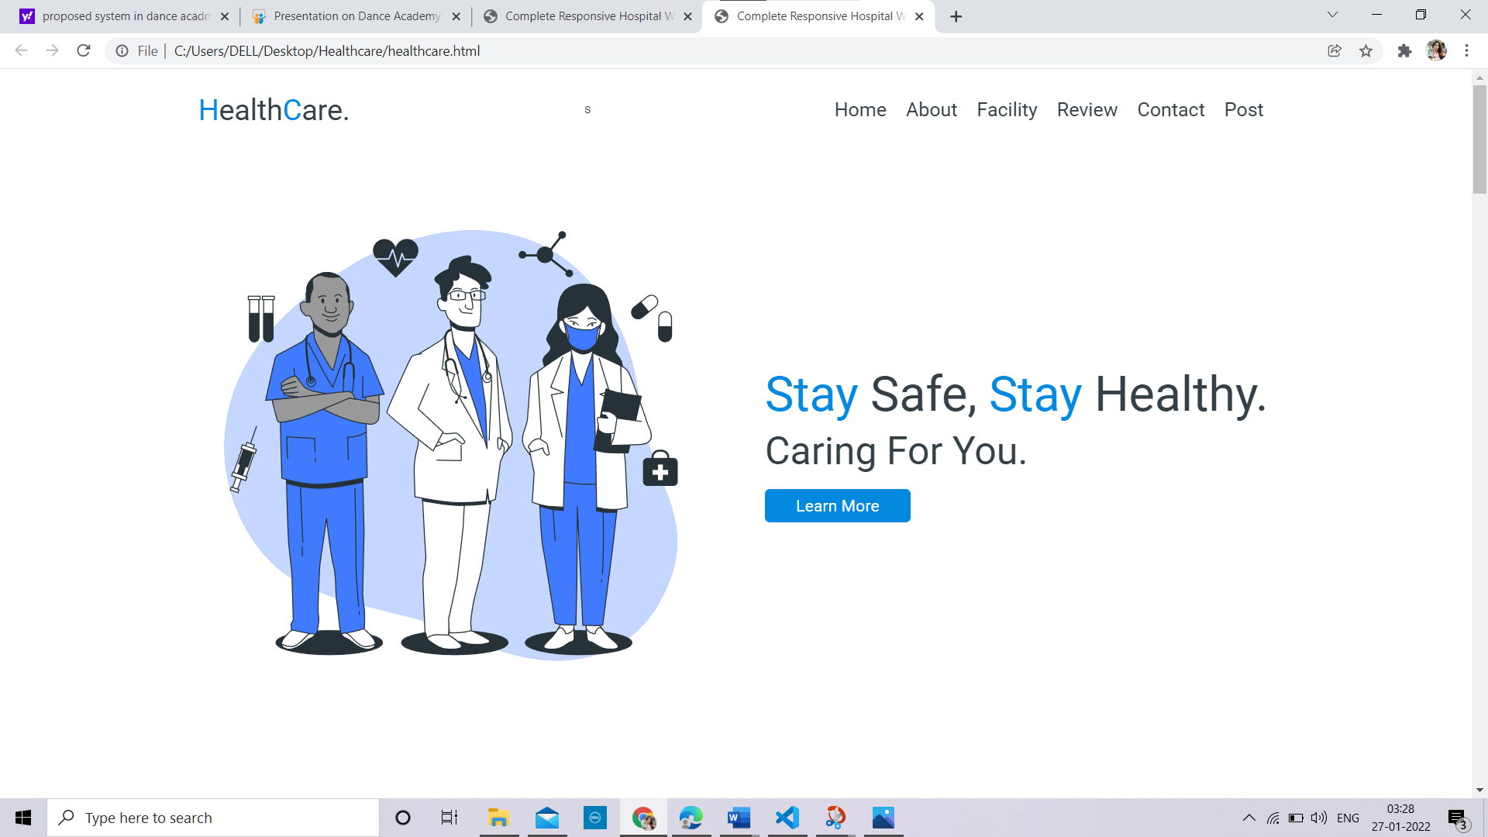

**Fig. 5.1 Home Page**

**5.1.2 About Us**

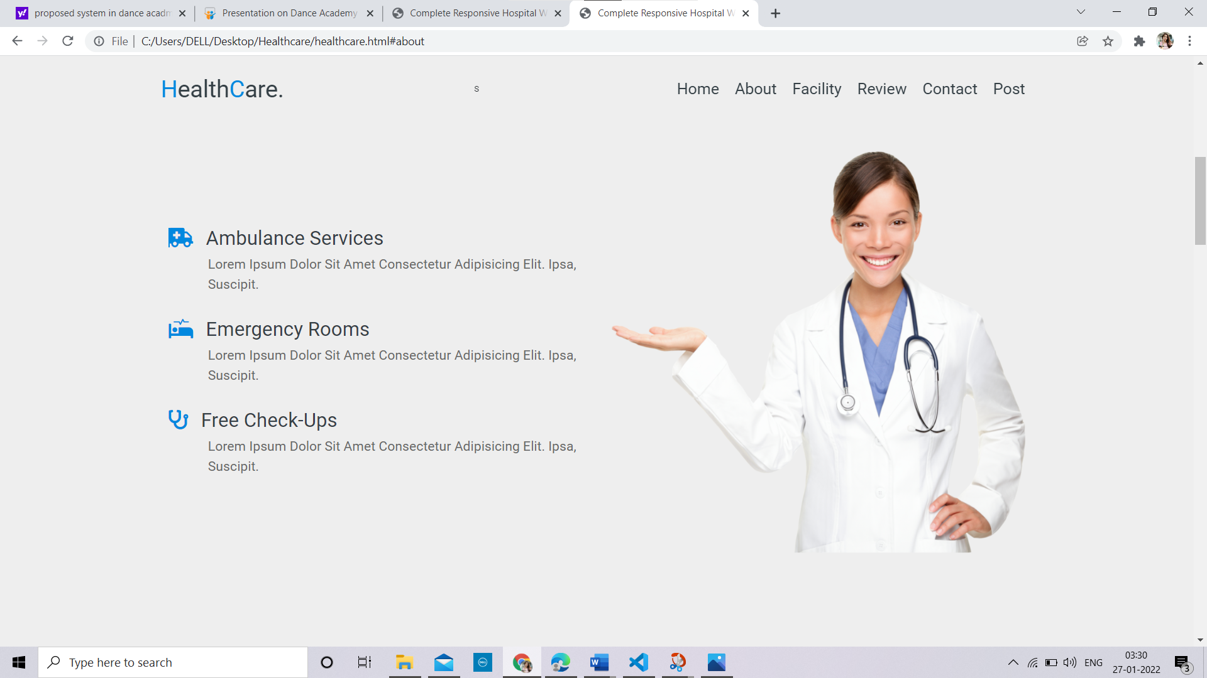

**Fig. 5.2 About us**

**5.1.3 CONTACT US**

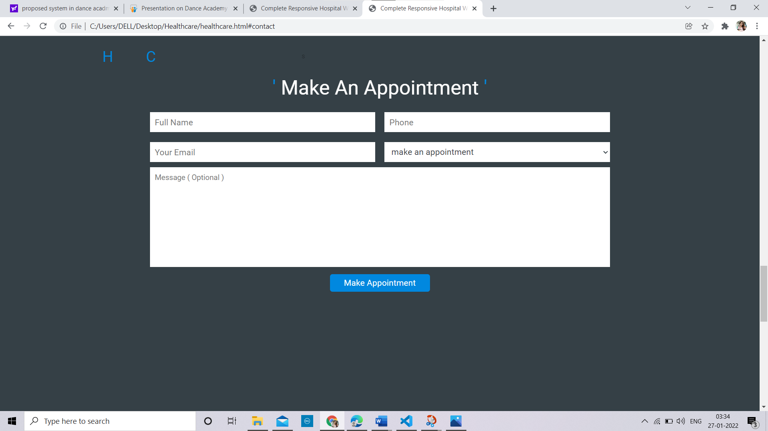

**Fig.5.3 Contact us**

**5.1.4 LOGIN PAGE**